



01 / 18 / 2024 Version 1.0



Background Investigation Bureau Support Document

**1. Introduction of BIB**

We are an AI enabled background screening company that delivers fast, accurate background checks with a conscience. Our screens are not just high-quality background screens, but we give every employer the ability to find out more truth about their future team members. At the intersection of Accuracy and Humanity is where you find the truth. We want to ensure every deserving candidate gets a chance at meaningful work and volunteer opportunities. This is us becoming part of the solution of a kinder and more productive world.

By bringing a sense of humanity to the screening experience, we keep people and their workplaces safe while creating opportunities for those who deserve it. This is hiring for humanity.

**What we offer:**

**Superior technology that ensures speed and accuracy**. Using AI-powered, next-gen tech creates client confidence. Knowing they’re using the newest tech makes them understand they’re getting the best results.

**Ease of use.** Our technology solutions make the process easy for both applicants and customers.

**Customer service**. Our service ratings are among the best across many industries. Clients know that they will get immediate and comprehensive customer service.

**A unique, context-focused approach.** Our context-based hiring allows customers to get a real picture of their candidates, ensuring that they hire the right person for the right job.

**2. How to enable the integration**

A user must have a **company admin** role in Teamtailor in order to be able to set up the integration.

If you are connected with BIB then simply ask BIB for the **BIB API Key** and **Email ID** associated with BIB for your company. You have to put in the API Key and Email ID at the time of activation. If you aren't associated with BIB, then simply connect with BIB and get the information as mentioned above. The contact details for Client Support is given below.

Email ID : [clientservices@bib.com](mailto:clientservices@bib.com)   Phone : 704-439-3900

For the activation process you have to submit the following details.

1. BIB API Key

2. Email associated with BIB

Please find the screenshot given below.

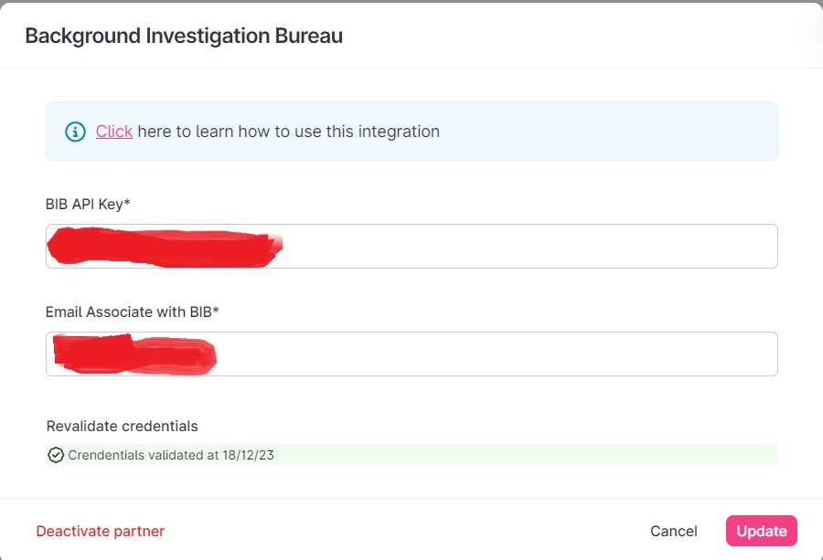

**3. Details regarding the integration**

# **Candidate Data needed for background check :**

There is some required/mandatory candidate information needed for the background check; please check the required fields listed below.

* First Name
* Last Name
* Date of Birth
* Email
* SSN
* Address
* City
* State
* Zip Code
* Sex

Optional Fields

* Address 2
* Middle Name
* Suffix

The First Name, Last Name, Email are the mandatory fields in Teamtailor but Date of Birth, SSN, Address, City, State, Zip Code and Sex is not a default field in Teamtailor. So for that you have to create Custom Fields and put in all required information before triggering the Background Investigation Bureau Event. Please check how to create the Custom Fields and where you will put all that information.

**IMPORTANT: You must fill out all mandatory fields or the background check will fail. In the case of missing information, the trigger will submit and return as failed. If a trigger fails in this way, please fill out all mandatory fields and resubmit the trigger.**

Steps are given below.

Steps:

1. Login your Teamtailor account with admin credentials. URL is as usual: <https://app.teamtailor.com/> Screenshot given below

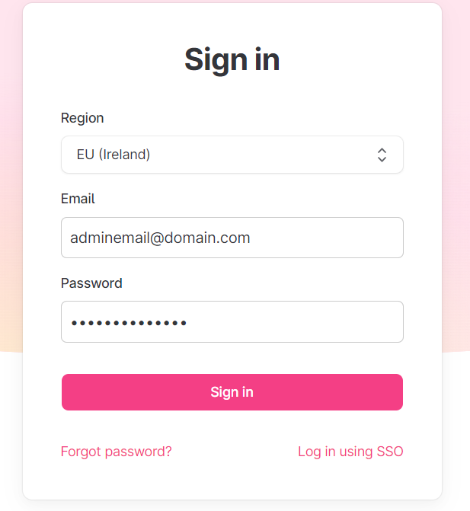

1. After logging in, you will find the dashboard screenshot given below.

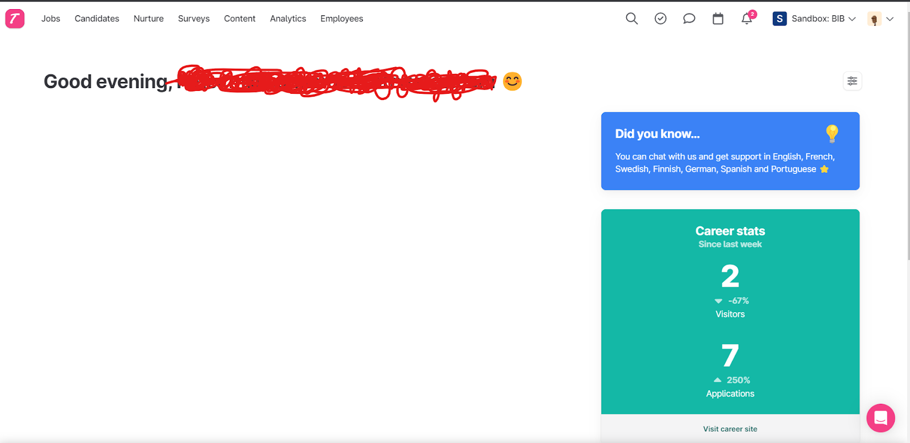

1. At the top right corner find the **Settings** link under the dropdown. Please check the screenshot given below for reference.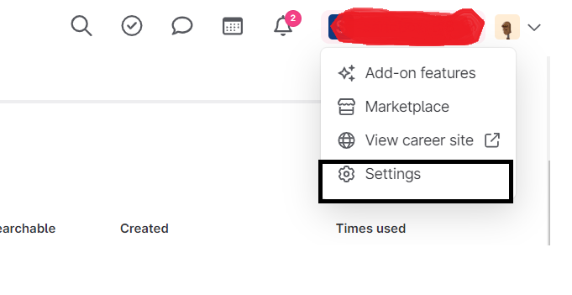
2. Once you click on the Settings link you will find the screen given below.

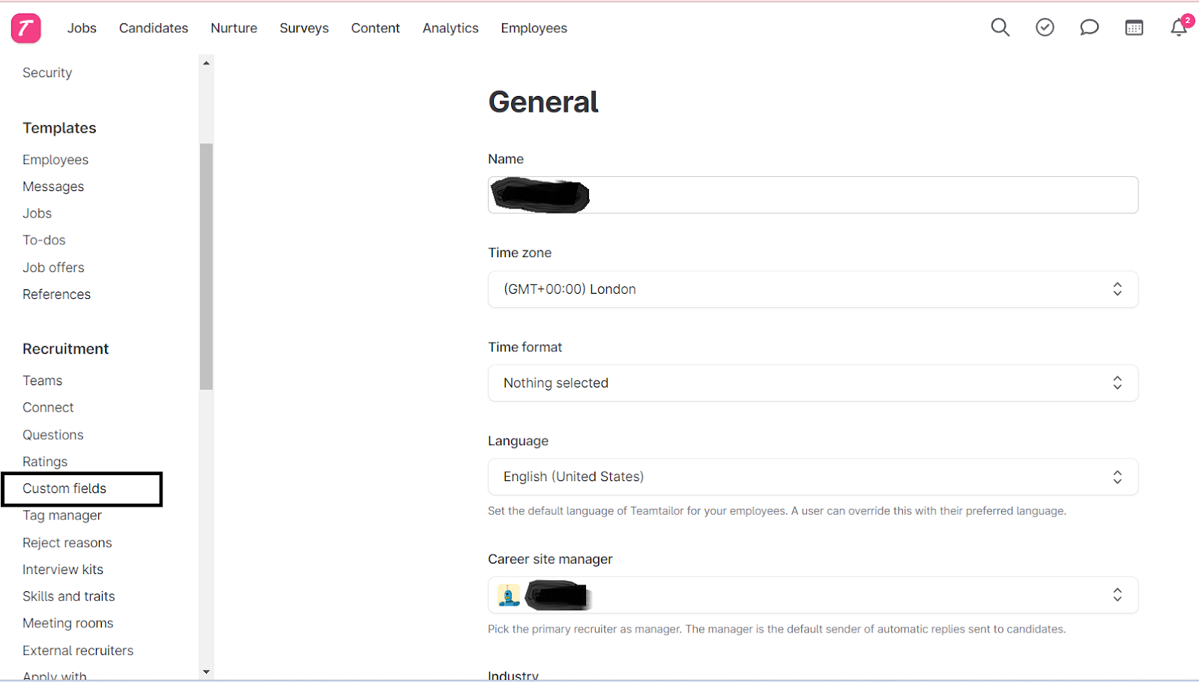

1. You will find the **Custom Fields** menu in the left menu bar under the **Recruitment** section, shown in the above screenshot in the rectangle. After clicking on Custom Fields, you will find the screen given below for your reference.

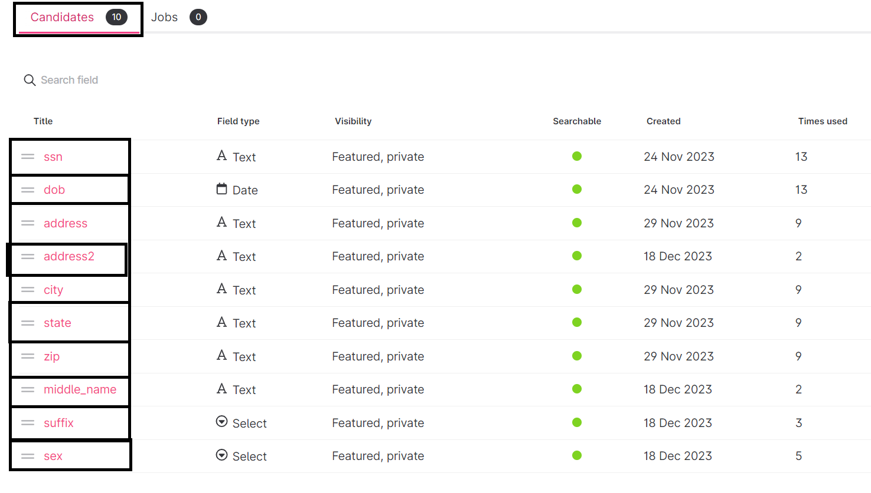

1. Find the **Candidates** tab and create the six fields demonstrated in the above screenshot with the same names as shown. You can find a button +New custom field. When you click on the +New custom field button you will find a few boxes, please see the screenshot given below.

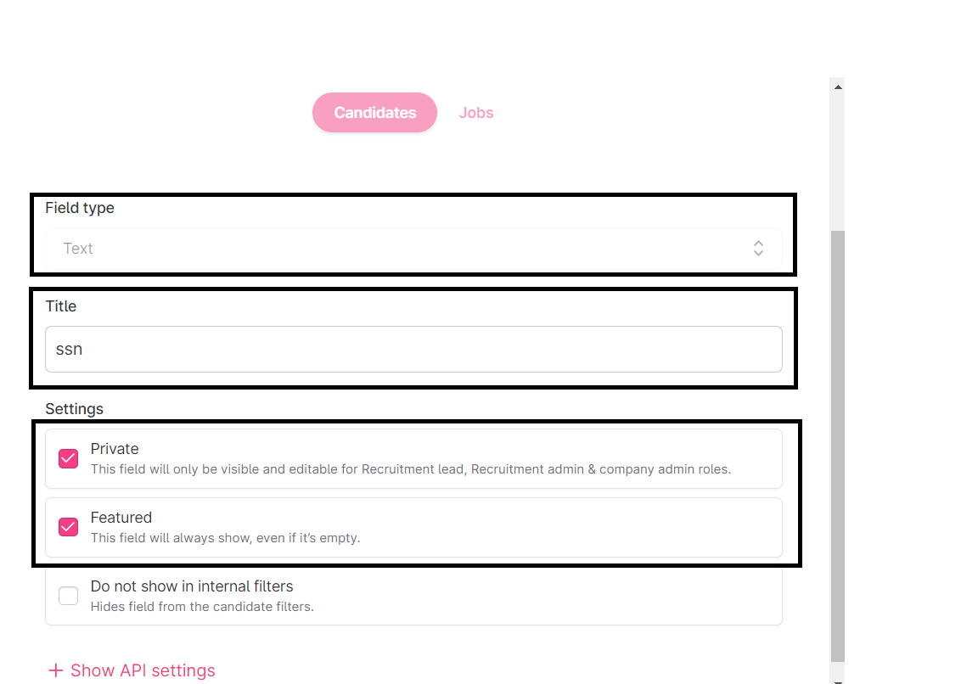

1. Under **Field Type** choose which type of field will be there. Under the title, put the name of the field and settings. Check the first two checkboxes. The third checkbox depends on if you want to filter on the created field or not. Below you will find a table of all the custom fields that need to be created.

|  |  |  |
| --- | --- | --- |
| SI. | Field Name | Field Type |
| 1 | ssn | Text |
| 2 | dob | Date |
| 3 | address | Text |
| 4 | city | Text |
| 5 | state | Text |
| 6 | zip | Number |
| 7 | address2 | Text |
| 8 | middle_name | Text |
| 9 | suffix | Select(JR, SR, III, IV, V) Max Three Letters |
| 10 | sex | Select(M, F, X, or U  ) Max One Letter |
|  |  |  |

Note: Names of fields are Case Sensitive, so please create the Custom Fields as instructed with the same name and type exactly as shown above.

# **How to put the required information on the candidate profile**

To see where you enter all the information in the candidate profile, just go to the job sections and click on the applicant, a popup will be shown. Please see the screenshot given below.

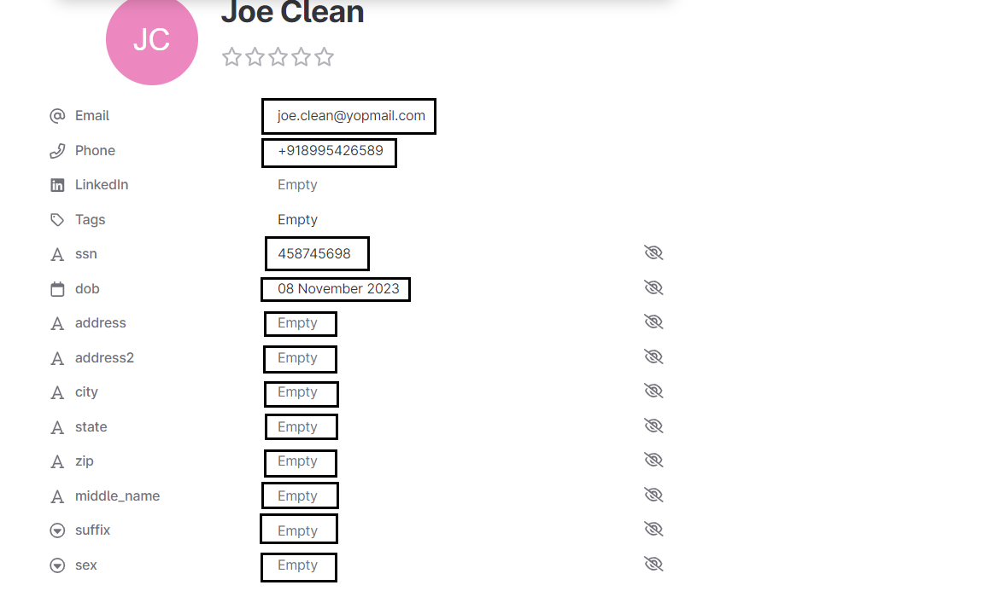

Note: Please make sure the applicant/candidate information is filled in before requesting a BIB background check.

# **How to set Background Investigation Bureau as a trigger to send the background check**

After installation and activation of Background Investigation Bureau, you can set the trigger at any stage where you want Background Investigation Bureau to start automatically.

Please follow the steps for setting up the trigger on the desired stage

Steps:

1. Go to the **Jobs** section, please check the screenshot below.

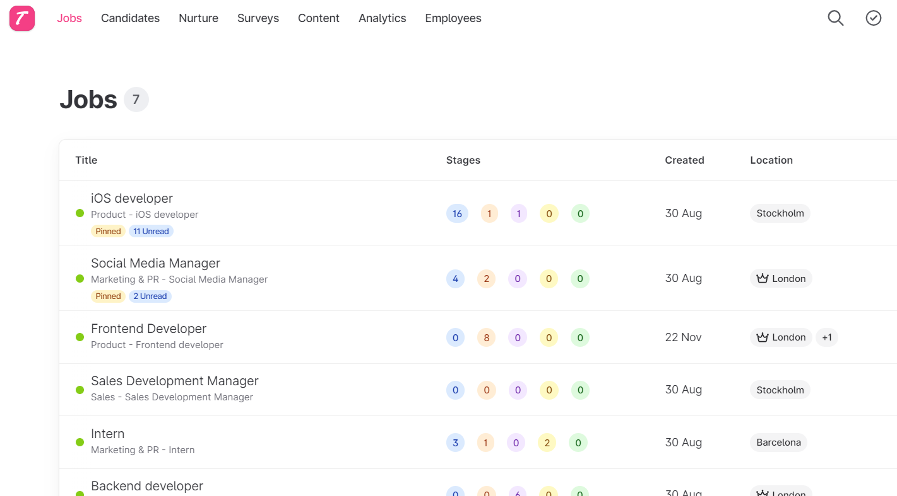

1. Click on any job and you will find the screen as shown below.

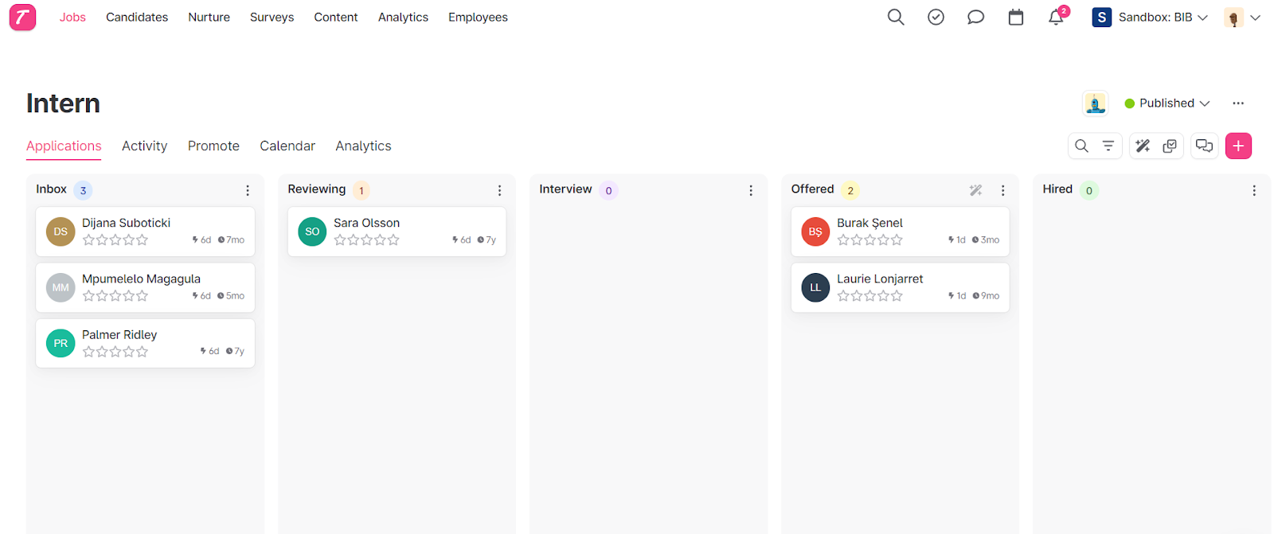

1. Find the **Trigger Icon** on the top right section of stages and click on the icon. Please refer to the below screenshot.

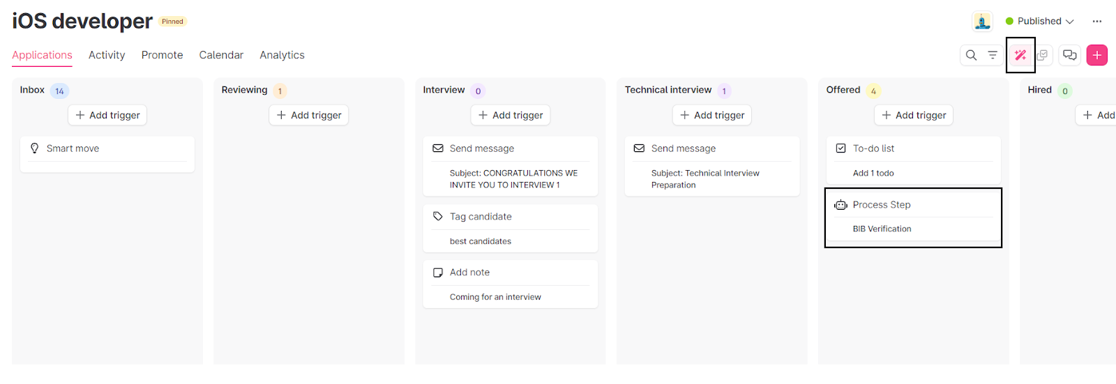

1. Now you can click on the **Add Trigger** button on the stage where you want to send  candidates to Background Investigation Bureau for Background Check. Please find the screenshot given below.

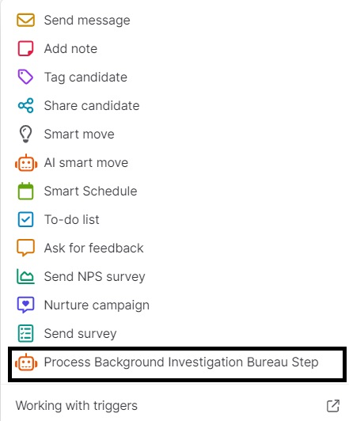

1. Now choose the **Process Background Investigation Bureau** from the list of triggers. Once chosen, you will find some options there. Please check the screenshot below.

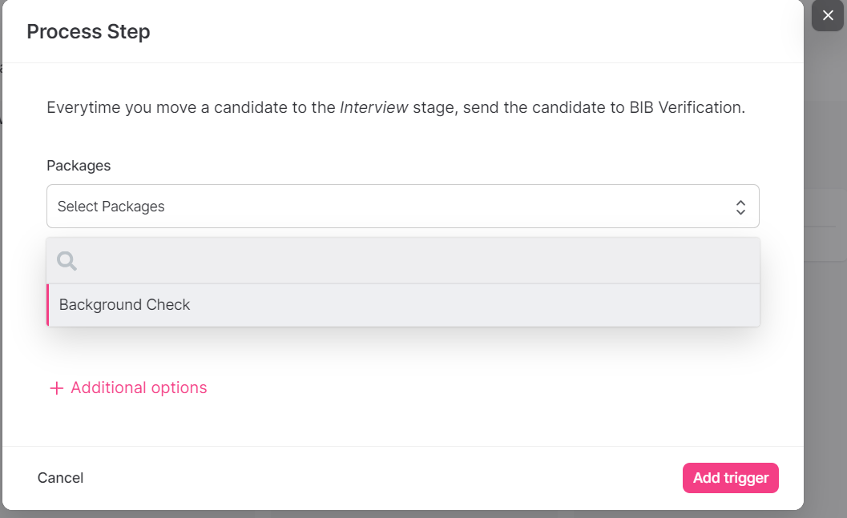

1. Choose the background check from **Packages** dropdown and you can also choose the move selection or rejection to any stage, please see the screenshot given below.

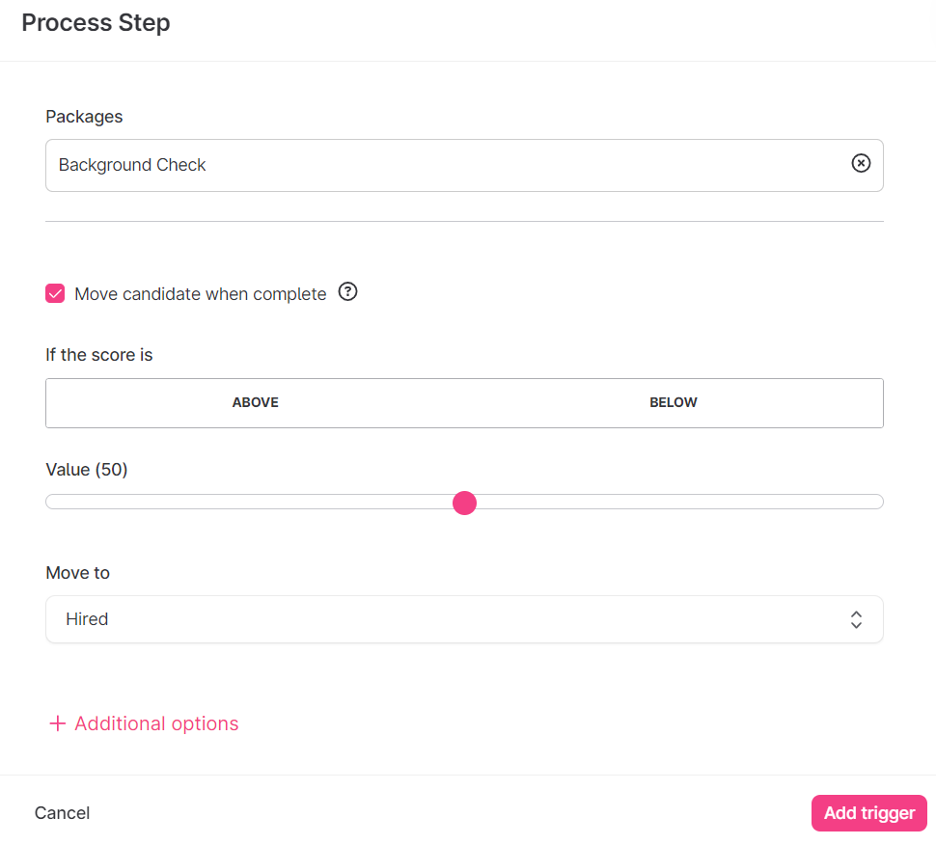

1. There are additional options where you can delay the trigger for a short span of time, please check the screenshot below.

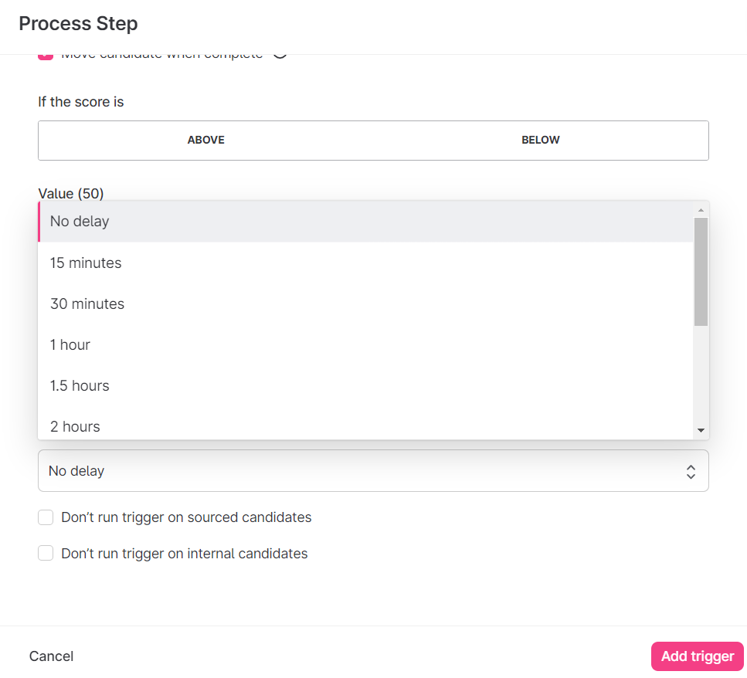

1. After that, click **Add Trigger** and the Background Investigation Bureau trigger will be placed on that stage. Please check the below screenshot for reference.

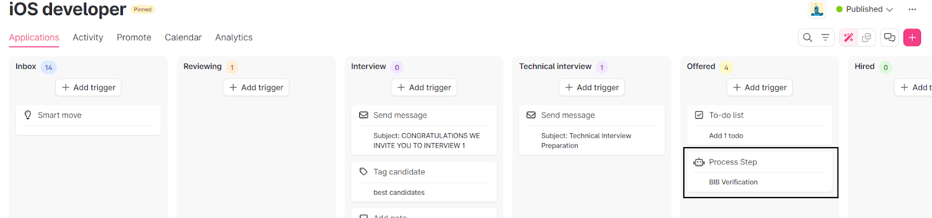

1. If you want to go back to your previous candidate list screen, just click on the **Trigger Icon** again and you will see the candidates in stages, please see the screenshot below.

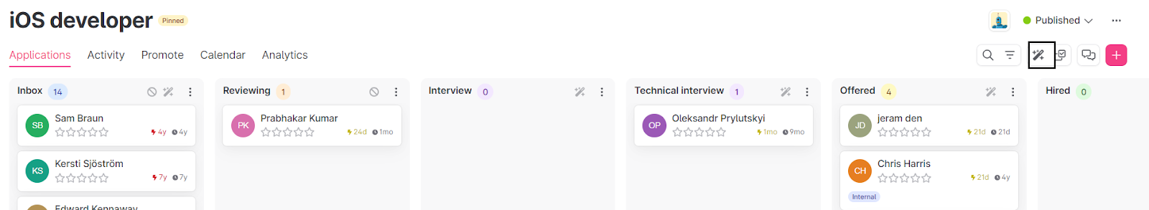

1. Now you can see the trigger icon is no longer highlighted.

**4. Support**

For any type of inquiry you can contact our Client Support team, details are given below.

Email ID : [clientservices@bib.com](mailto:clientservices@bib.com)   Phone : 704-439-3900